**IMPLEMENTATION OF PUBLIC UTILITY JEEPNEY DISEMBARK POINTS ALONG**

**QUIRINO AVENUE NEAR VICTOR MEDINA AND QUIRINO AVENUE INTERSECTION**

**Jheanne Rona A. Aguilar Cristopher A. Avanzado**

*College of Science College of Science*

*BSCS-3AB BSCS-3AB*

*Manila, Philippines Bulacan, Philippines*

[*jheannerona.aguilar@tup.edu.ph*](mailto:jheannerona.aguilar@tup.edu.ph)[*cristopher.avanzado@tup.edu.ph*](mailto:cristopher.avanzado@tup.edu.ph)

**Foehn Raja P. Dela Cruz Kurk Van H. Punzalan**

*College of Science College of Science*

*BSCS-3AB BSCS-3AB*

*Parañaque, Philippines Parañaque, Philippines*

[*foehnraja.delacruz@tup.edu.ph*](mailto:foehnraja.delacruz@tup.edu.ph)[*kurkvan.punzalan@tup.edu.ph*](mailto:kurkvan.punzalan@tup.edu.ph)

***ABSTRACT –* One of the domino effects of hours of traffic delays is the enormous lines of people waiting for jeeps. Along with the long commute times for the general people, another problem was the increase in private vehicles and decrease in truck traffic, particularly when the epidemic first began. Each scenario is designed to maximize the effectiveness of public transportation vehicles while avoiding the main causes of traffic congestion on Quirino Avenue. Using AnyLogic Simulator, a DES model is created from the traffic flow scenario at the intersection of Victor Medina and Quirino Avenue.**

1. **INTRODUCTION**

The increased number of public and private transportation, mostly centered on the NCR cities, is now causing car, and commuting concerns for the general population. Heavy traffic is nothing new for public commuters; but, avoiding traffic congestion on buses and jeepneys is becoming increasingly difficult. Although proper stations and terminals are created along these cities' roadways, they are insufficient for daily travelers. Even before the epidemic, Filipinos have been concerned about traffic and public transportation.

One of the current issues leading to public commuters' agony is public vehicles stopping everywhere to fill their cargoes with people, causing traffic congestion and even human traffic flow. Long lines waiting for a bus, or a jeep are one of the knock-on effects of hours of gridlock. The increase in private automobiles, particularly when the epidemic began, adds to the public's extended commute hours. In 2018, the number of automobiles crossing EDSA daily was 251,628, significantly outnumbering the average number of public transportation buses, which was 13,356. In 2017, public utility buses accounted for barely 3% of EDSA traffic. Private cars filled 67 percent of the road. Unfortunately, this did not stop the MMDA from testing a provincial bus ban in August.

Another issue that contributes to the public's everyday traffic commute is road quality. In November 2011, just 45 percent (14,200 km) of the system's 31,400 km of national roadways were deemed suitable or acceptable. They compared this figure to the numbers in 1982 (about 52%) and 2001. (about 47 percent). In 2009, the share for local roads was much lower, at roughly 20%. (or around 35,300 km of 176,300 km). Annually, about 0.6 percent of GDP is still invested in road infrastructure, which is 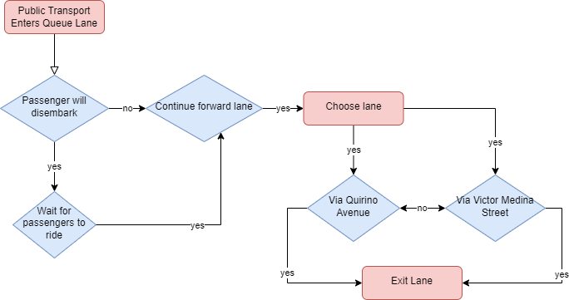much less than the comparable number for other Southeast Asian countries. As a result, little attempts have been made to enhance or expand the network.

The usual traffic of public commuters indicates concern along the highways of Quirino Avenue and Victor Medina Intersection in Parañaque City, with jeepneys clustering along the right-side lane, using significant time waiting for passengers while obstructing the principal side of the road. All of the variables include traffic congestion caused by public transit, private automobiles, human traffic flow, and road condition.

1. **ROAD ANALYSIS AND PROCESS OVERVIEW**
2. **Traffic Flow Lane Flowchart**

A typical public commuter has two options for waiting for transit to work. Their first option is to wait in the terminal lane, where automobiles are waiting for passengers, and their second alternative is to catch passing public transit with empty seats and ride to work. Vehicles from one avenue may go to the highway and select forward or reverse lanes. Most public transportation vehicles pull over to the side of the roadway to pick up passengers. Public commuters are selective about what they ride, resulting in a long line of public transit waiting for passengers ready to fill the vehicle's capacity load.

Every scenario performed is designed to maximize the efficiency of public transportation vehicles while avoiding the source of traffic congestion along Quirino Avenue and the Victor Medina Intersection. Figure 1 displays a simple schematic of switching lanes and the suitable lane for public vehicles to pick passengers.

**Fig 01**. Traffic Flow Lane Flowchart of Quirino Avenue and Victor Medina Intersection Roadmap

1. **Road Map and Network**

The road network mapping from Quirino Avenue to the intersection of Quirino Avenue and Victor Medina is not complicated, but it nevertheless provides grounds for traffic congestion. The researchers chose to extract the road layout from Google Earth, beginning with the route along Quirino Avenue and ending at the Victor Medina Intersection. The unlawful lane on the right side of the road where they pick up and drop off passengers is the most common source of traffic bottlenecks, posing substantial hazards and risks for vehicles and public commuters on the sidewalk. The route runs through a business neighborhood with convenience stores and fast food restaurants, resulting in increased car traffic. Figures 2 and 3 show a comparison of the road map through satellite from Google Earth and the redesigned version with queuing lanes.

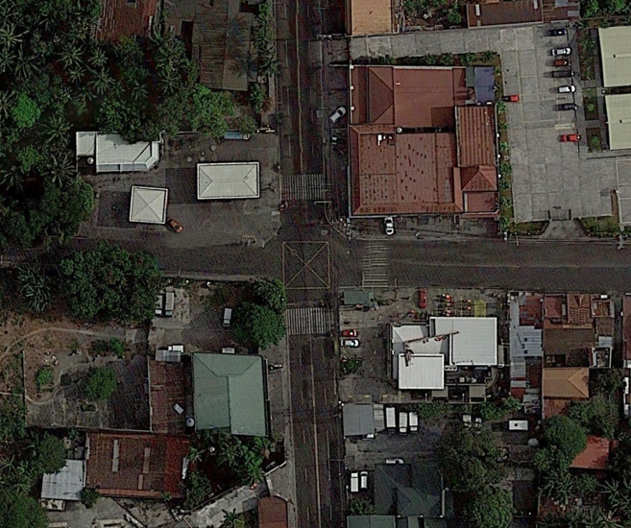

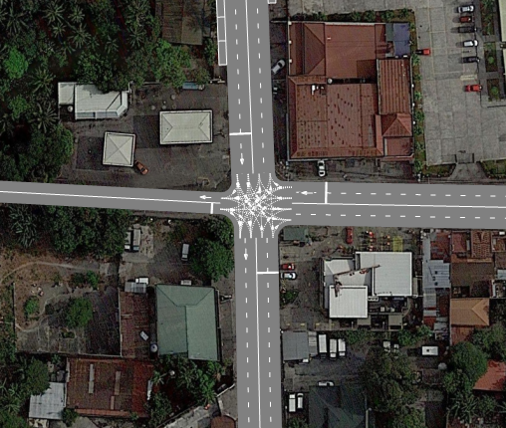**Fig 02**. 2D satellite view of the roadmap

**Fig 03.** Remodeled version of the roadmap using Anylogic

1. **DISCRETE-EVENT SIMULATION MODEL**

Discrete-event simulation (DES) is commonly used to model and mimic actual occurrences using appropriate software. When the entity under investigation may be described as a series of activities, DES modeling approaches must be used. A DES model is created using AnyLogic Simulator using the traffic flow situation along Quirino Avenue and the Victor Medina Intersection. AnyLogic is a simulation modeling tool that supports several simulation methods. It supports dynamic response, discrete event, and agent-based approaches, as well as a cross-platform emulation program that works on Windows, macOS, and Linux.

The automobile blocks were employed by the researchers to mimic movement and vehicle orientation. Car-source, car-dispose, car move-to, and road network descriptor are the car blocks utilized. There are two vehicle sources employed, one from Quirino Avenue and one from Victor Medina Street. The car source shows where automobiles are inserted into a certain area in the road network. This pick output has two ports to link with, and only two of them are used to connect the queue lanes, Quirino Avenue and Victor Medina Street.

The first car move-to lane from the first out-port is labeled for the queue lane; the car move-to determines the direction of each vehicle entering the road; it is ordered to have a wait of 0.5 second. The persons riding and departing public transportation cause the delay. The public vehicle has two routes to choose from: Quirino Avenue or Victor Medina Street. Another choose output with two ports is utilized to depict this direction. Other cars may turn immediately on Quirino Avenue and via Victor Medina Street, bypassing the Queue lane, which is reserved for public vehicles exclusively.

Another automobile source would be from Victor Medina Street, however it would only be possible to use one road because Victor Medina Street and Quirino Avenue are both one lane. Car-dispose represents all automobiles quitting the road. The 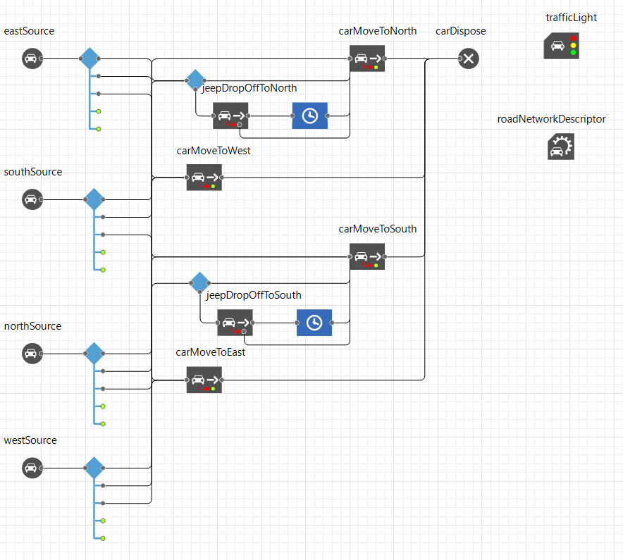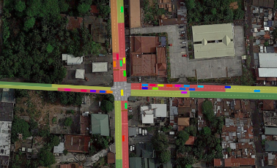fundamental direction model is depicted below:

**Fig 04.** Direction flow code for the simulation

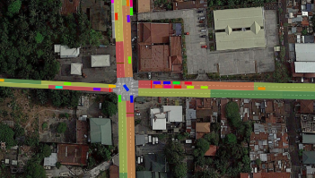***Traffic Density***

Traffic density is an important macroscopic characteristic of traffic flow that is used to evaluate transportation efficiency from the standpoint of users and administrators. It is also employed as the major control parameter in highway regulation and tracking systems. It displays the level of traffic congestion on the roadways. When the density hits its limit and the flow is zero, traffic congestion occurs. The density is determined as m denotes the number of autos present along a road section of length L.

Two scenarios are assumed and described in AnyLogic Simulator to demonstrate the difference between real-time and the alternate approach for the traffic bottlenecks on Quirino Avenue. Green marks indicate a speed of 60 km/h, whereas red markings indicate a speed of 10 km/h. This means that the

quicker the vehicle, the smoother the traffic flow and lower the traffic density, whereas the slower the speed, the greater the traffic density and congested traffic flow.

**Fig 05.** Traffic Density of real-time traffic flow along Quirino Avenue

**Fig 06.** Traffic Density of Simulated Scenario of Queue Lane Implemented

In comparison, traffic congestion collected in Fig 5 began to have red marks alongside the mall on the left side. On the other hand, as demonstrated in Fig 8, the example simulation of adding wait lanes for public transportation vehicles appears to be quite a handful in preventing congestion and traffic jams and is efficient for both private and public cars and passengers. However, as seen in Fig 8, the sample simulation of adding wait lanes for public transportation vehicles appears to be highly useful in preventing congestion and traffic jams and is efficient for both private and public vehicles and passengers. Both simulations are timed, lasting one hour from 4 to 5 p.m. The time specified in the simulation is the most documented in real-time for the "rush hour" of passengers looking for a trip home, with a higher number of automobiles on the avenue.

1. **CONCLUSION**

When the two scenarios were compared, each produced significant data that indicated the efficiency of adding queue lanes along Regalado Avenue. The road network descriptor is used to compare the traffic density of real-time and experimental simulations along these roadways. Traffic congestion and car bottlenecks are unavoidable; nonetheless, finding practical solutions to these problems helps not just drivers but also public commuters in the country. Adding queue lanes demonstrates and validates its efficiency and efficacy. Not only are additional lanes opened to prevent being delayed between public vehicles dropping off or picking up people, but more lanes are opened to easily go in the direction cars are traveling.

Of course, the discipline of public commuters and drivers to stick to the queue lanes are uncontrolled aspects that must be taken into account in future research. This modeling and simulation serve as a reference and recommendation to the authorities in order to assist enhance the condition of the road network along Quirino Avenue and Victor Medina Street. This study is confined to the mentioned road networks, and the efficacy may differ for various sites in Philippine cities. Queue lanes assist in mitigating the underlying implications and current concerns of traffic congestion in the country, as well as improving such stops and terminals by simply having a delay rather than a waiting line for public vehicles.

**REFERENCES:**

* Ibryaeva, O. L., Shepelev, V. D., Kuzmicheva, O. D., Аlmetova, Z. V., Zhulev, A. E., & Cherpakov, A. O. (2021). A study of the impact of the transport queue structure on the traffic capacity of a signalized intersection using neural networks. Transportation Research Procedia, 52, 589–596. https://doi.org/10.1016/j.trpro.2021.01.070
* L. Bloomberg, J. Dale. Comparison of VISSIM and CORSIM traffic simulation models on a congested network. Transportation Research Record: Journal of the Transportation Research Board, 1727, pp. 52- 60 (2000) 27. Federal High
* A. Halati, H. Lieu, S. Walker. CORSIM-Corridor Traffic Simulation Model. In Traffic Congestion and Traffic Safety in the 21st Century: Challenges, Innovations And Opportunities (1997)